AIM-To perform algebra of matrix:
Addition,Subtraction,Multiplication,Transpose

ALGORITHM-
1.start
2.Enter no of rows and columns
3.enter elements of rows and columns i.e
for(i=0;i<rows;i++)
{ for(j=0;j<columns;j++)
{enter a[i][j] & b[i][j]
}
}
ADDITION

for(i=0;i<rows;i++)
{
for(j=0;j<columns;j++)
{
sum[i][j]=a[i][j]+b[i][j];
}
}
SUBTRACTION

for(i=0;i<rows;i++)
{
for(j=0;j<columns;j++)
{
sub[i][j]=a[i][j]-b[i][j];
}
}
MULTIPLICATION

if(r==c)
{ for(i=0;i<rows;i++)
{
for(j=0;j<columns;j++)
{
mul[i][j]=0;
mul[i][j]+=a[i][j]+b[j][i];
}
}
}

TRANSPOSE

for(i=0;i<rows;i++)
{
for(j=0;j<columns;j++)
{
a[i][j]=b[j][i];
} }
CODE-
#include<iostream>
using namespace std;
int main()
{
int a[5][5],b[5][5],c[5][5],sum,r1,c1,r2,c2,i,j,k,choice;
cout<<"Enter rows and columns of first matrix:";
cin>>r1>>c1;
cout<<"Enter rows and columns of second matrix:";
cin>>r2>>c2;
cout<<"\nEnter first matrix:\n";
for(i=0;i<r1;++i)
{
for(j=0;j<c1;++j)
{
cin>>a[i][j];
}
}
cout<<"\nEnter second matrix:\n";
for(i=0;i<r2;++i)
{
for(j=0;j<c2;++j)
{
cin>>b[i][j];
}
}
do
{
cout << "Matrix operations\n1: Addition\n2: Subtract\n3: Multiply\n4: Transpose\n5: Exit\nEnter your choice :";
switch (choice)
{
case 1:
for(i=0;i<r1;++i)
{
for(j=0;j<c1;++j)
{
c[i][j]=a[i][j]+b[i][j];
}
}
cout<<"Addition of the two matrices is:\n";
for(i=0; i<r1; ++i)
{
for(j=0; j<c1; ++j)
{
cout<<c[i][j]<<" ";
}
cout<<"\n";
}
break;
case 2:
for(i=0; i<r1; i++)
{
for(j=0; j<c1; j++)
{
c[i][j]=a[i][j]-b[i][j];
}
}
cout<<"Subtraction of the two matrices is :\n";
for(i=0; i<r1; i++)
{
for(j=0; j<c1; j++)
{
cout<<c[i][j]<<" ";
}
cout<<"\n";
}
break;
case 3:
for(i=0; i<r1; i++)
{
for(j=0; j<c1; j++)
{
sum=0;
for(k=0; k<r1; k++)
{
sum = sum + a[i][k] * b[k][j];
}
c[i][j] = sum;
}
}
cout<<"\nMultiplication of two Matrices : \n";
for(i=0; i<r1; i++)
{
for(j=0; j<c1; j++)
{
cout<<c[i][j]<<" ";
}
cout<<"\n";
}
break;
case 4:
for(i=0; i<r1; i++)
{
for(j=0; j<c1; j++)
{
c[i][j]=a[j][i];
}
}
cout<<"Transpose of the Matrix is :\n";
for(i=0; i<r1; i++)
{
for(j=0; j<c1; j++)
{
cout<<c[i][j];
}
cout<<"\n";
}
break;
case 5:
break;
default:
cout << "Invalid input" << endl;
}
}while (choice != 5);
}

OUTPUT-

Addition-
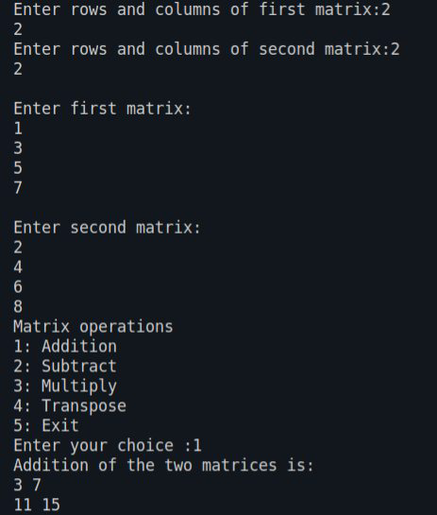

SUBTRACTION-
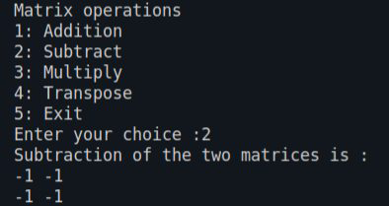

MULTIPLICATION-
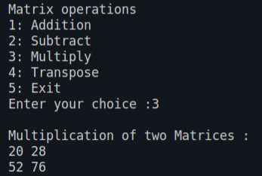

TRANSPOSE-
